D e v a y a n i
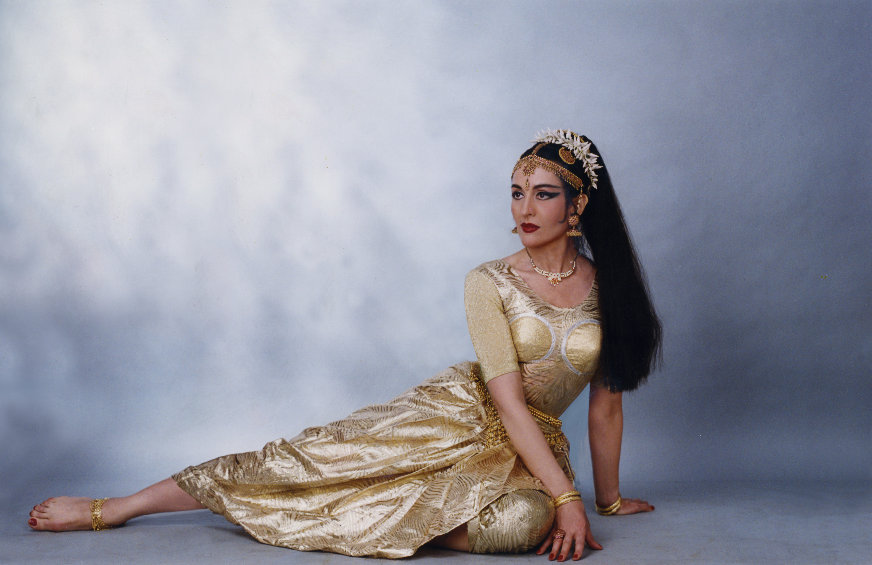

Bharata Natyam Dancer & Choreographer

Devayani trained under the "Masters in the Bharata-Natyam dance tradition" of the temple cities of South India, Kancheepuram Ellapa Mudaliar and Kalaimamani V.S. Muthuswamy Pillai. Born in Paris she took Indian audiences by storm with her acting and dance performances in the lead role of the Telugu film "America Ammayi".
Devayani, through her stunning and magnetic personality has established herself as one of the very few outstanding exponents of Bharata Natyam in India and on the international scene. Devayani has performed in prestigious theatres & Festivals in all the European & Scandinavian countries, Estonia, Korea, Nepal, Bangladesh etc. Her show “Like a Goddess” received a Four Star ranking from the British Press at the International Edinburgh Festival Fringe in 1997. In the Year 2000 Devayani was given top billings along with the maestro of opera singing Luciano Pavarotti and the star of the Kirov Opera Olga Borodina at the XXIV Algarve International Music Festival in Portugal.
Devayani is the Winner of The IMM Top Cultural Ambassador Award for Excellence and was conferred the National Women Excellence Award & the Padma Shri Award, one of the highest National Indian Civilian Awards for her outstanding artistic achievements & contribution to the promotion and perpetuation of Bharata Natyam internationally. Devayani was selected by the Ministry of Tourism for the Incredible India Campaign titled ‘Real People’ and a 20 feet hoarding with her Bharata Natyam pose was displayed in Times Square, New York.
highlights
stage France Palais des Congres, Salle bleue, Paris
Switzerland Award at International Choreography Contest, Nyon
Finland Savoy Theatre, Helsinki, Pt. Jawaharlal Nehru Centenary Celebrations
Luxembourg Villa Louvini in concert with Laxmi Shankar
U.K. Purcell Room, Queen Elizabeth Hall, London
International Edinburgh Festival
October Gallery, Commonwealth Institute, ' Dance World ', London
Estonia 'Orient 98', Tallinn, Eesti Concert Hall
Germany Indian Cultural Centre, Tagore Centre, Berlin
Portugal XXIV Algarve International Music Festival
Italy 'Indian Landscapes', Argilla Teatri, Rome
South Korea world culture open, Seoul
Greece 'India Vision ', Athens, 50th Anniversary of India's Independence
Hellas Dance Festival, Veakion Amphitheatre, Athens
Pierce Theatre, The American College of Greece, Athens
20th & 21st World Congress on Dance Research, , Athens
In India : Rasika Ranjani Sabha, Madras; Tata Theatre, Bombay; Kamani Auditorium, New Delhi; Rabindra Sadan, Calcutta; 'Divisional Utsav'; 'Swami Haridas Sangeet Sammelan'; 'Golden Greats Festival' ITC,Jodhpur ,’Taj Mahotsav,’Kalidas Festival’,’Taramati Festival Music & Dance Festival’, Sanskriti Utsav,Ellora Ajanta Festival,
Lucknow Mahotsav, Buddha Mahotsav, Sri Sankat Mocham Sangeet Samaroh, Chakradhar Samaroh, Modhera Sun Temple Dance Festival, Mahakal Music & Dance Festival Ujjain,Jhansi Mahotsav,Uday Shankar Dance Festival etc,.
quotes : "As radiant as the divine celestial dancer....gifted with a figure reminiscent of a Hindu Temple sculpture".
"Devayani has a powerful command of the Music....a sensuous and captivating stage presence"
cinema : Heroine of the Indian Film 'A Girl from America' acting, singing play-back; Kuchipudi dance sequence.
t.v. : Indian T.V. Network, FR3 (Paris), Zee T.V., Asia T.V., BBC, ITV, Net (Greece).
press : Covered by the Indian Media, the Media in US, UK, Europe, Eastern Europe & Scandinavia, Asia. Covered in TIME & NEWSWEEK magazines for Incredible India campaign ‘Real People’

E-mail: devayani_dance @ rediffmail.com;devayanidance10@gmail.com;kumari.devayani@facebook.com
Web: www.devayanidance.com, www.facebook.com/people/Kumari-Devayani, www.youtube.com/watch?v=6t0_UzDwuFA
Telefax: 00 91 11 26910538; Mob: 00 91 9810911944

